Social Media Ad Portfolio

Created by Poojitha

# Cinema Quality. Anytime, Anywhere.

# CONTENT:

# Image: A chic, modern living room setup with the projector displaying a high-quality image on a clean wall.

# Headline: "Cinema Quality. Anytime, Anywhere."

# Text: "Experience crystal-clear visuals with our compact, high-definition projector. Elevate your nights."

# CTA: "Order Now"

# 

# Experience crystal-clear visuals with our compact, high-definition projector. Elevate your nights

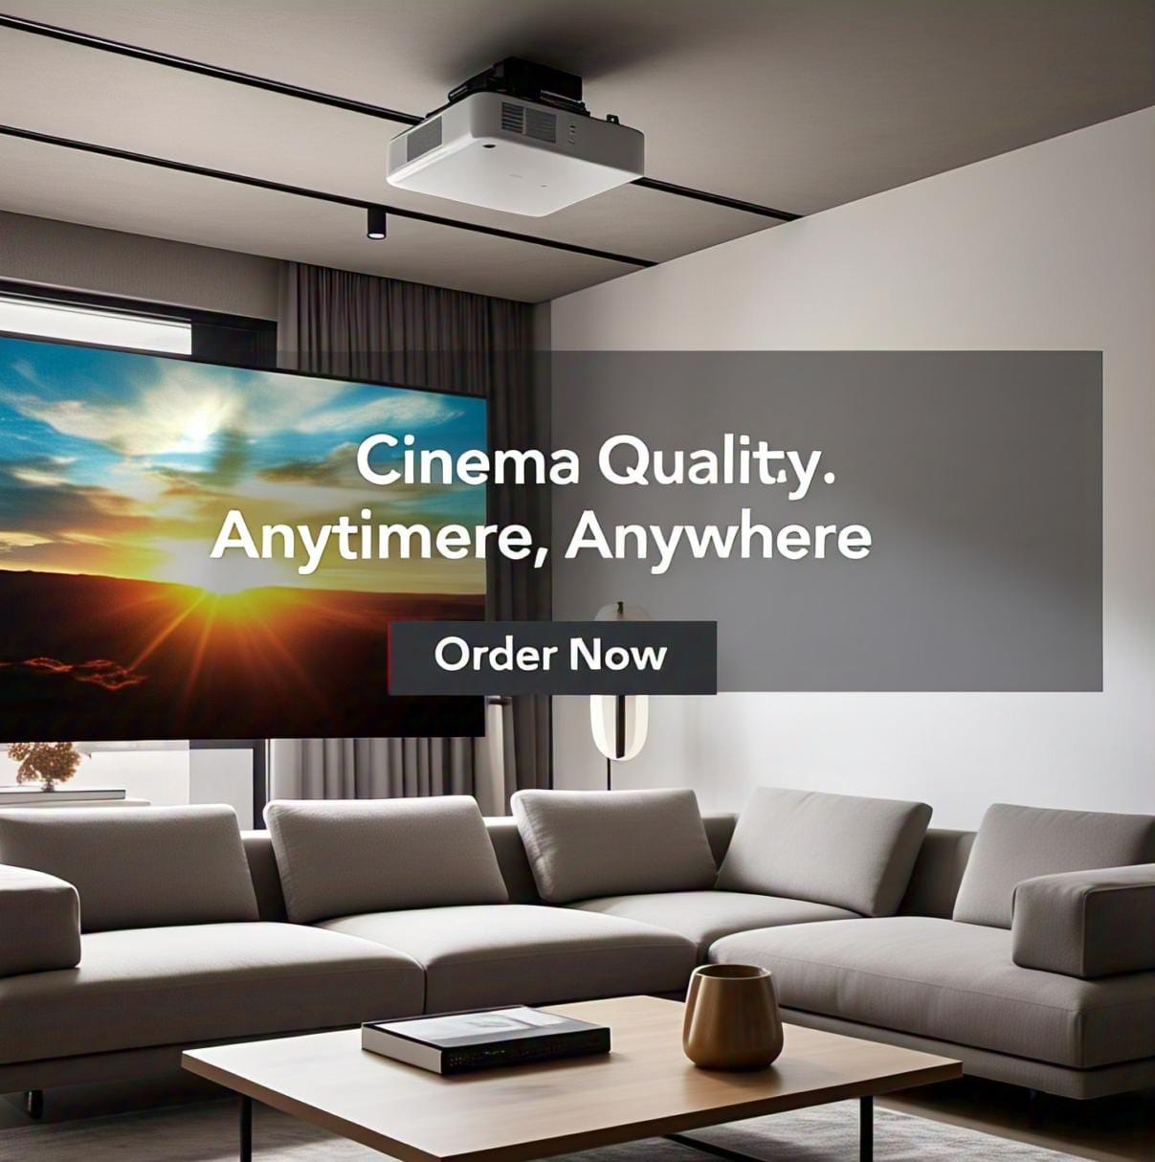

# Light Up Your World

**CONTENT:**

**Smart LED Strip Lights**

**Product: Color-Changing LED Strip Lights**

**Target Audience: Home decorators, gamers, and party lovers aged 16-35**

**Ad Content:**

**Image: A cozy bedroom setup with colorful LED lights glowing around the ceiling and desk.**

**Headline: "Light Up Your World"**

**Text: "Create the perfect vibe for gaming, parties, or relaxing with our smart LED strip lights."**

**CTA: "Shop Now"**

Create the perfect vibe for gaming, parties, or relaxing with our

smart LED strip lights

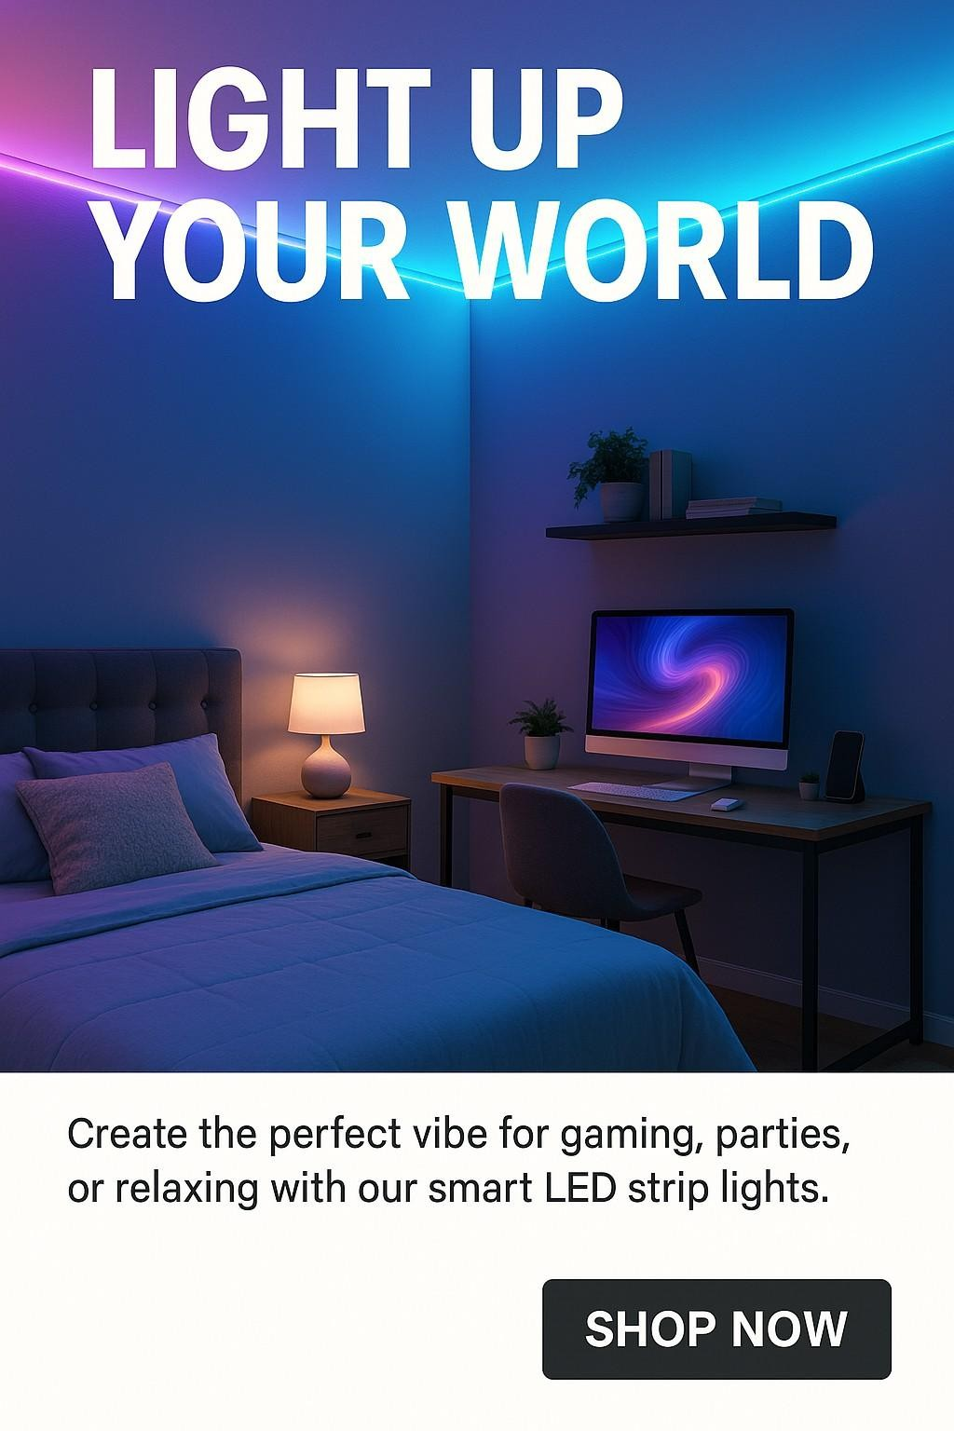

# Breathe Better, Live Healthier

**CONTENT:**

**Compact Air Purifier**

**Product: Portable Air Purifier Target Audience: Urban dwellers, parents, and pet owners aged 25-50**

**Ad Content:**

**Image: A small, stylish air purifier on a desk next to a laptop and houseplants.**

**Headline: "Breathe Better, Live Healthier"**

**Text: "Keep your air clean and fresh with our compact, quiet air purifier. Perfect for home or office!"**

**CTA: "Order Now"**

Keep your air clean and fresh with our compact, quiet air purifier. Perfect for home or office!

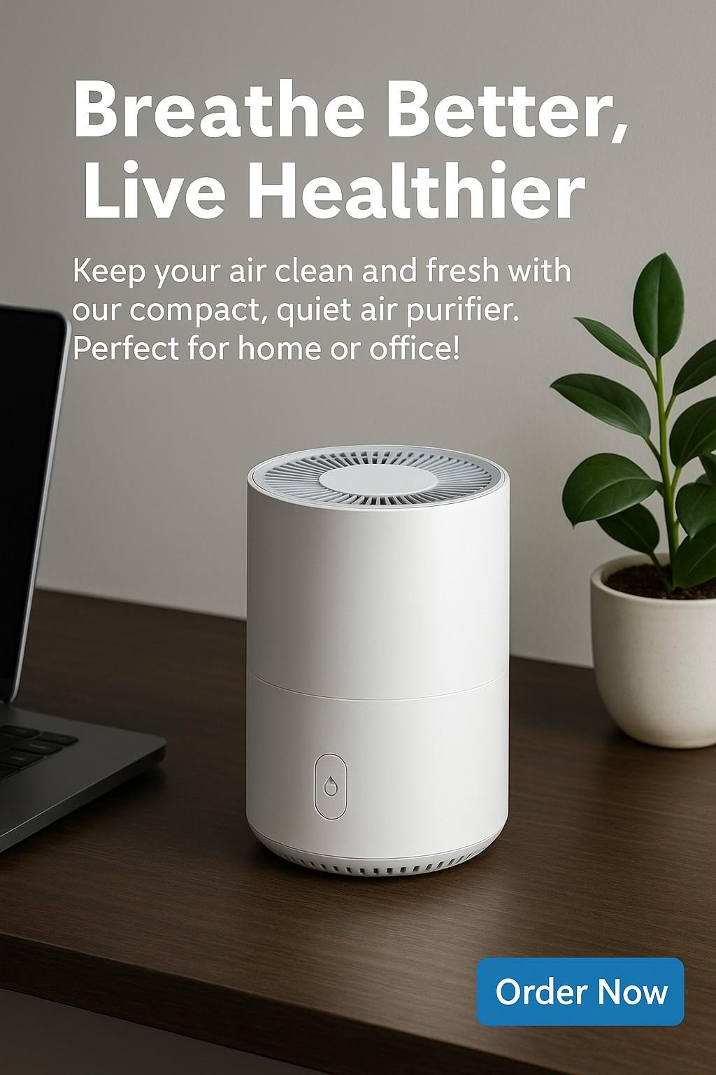

# Never Lose Your Keys Again!

**CONTENT:**

**Product: Smart Key Finder Target Audience: Busy people, students, and travelers aged 18-50**

**Ad Content:**

**Image: A hand holding a phone with a map screen showing the location of lost keys.**

**Headline: "Never Lose Your Keys Again!"**

**Text: "Track your keys, wallet, or bag in seconds with our smart Bluetooth tracker."**

**CTA: "Shop Now"**

Track your keys, wallet, or bag in seconds with our smart Bluetooth tracker

**AWARENESS BEGINS WITH YOU**

**CONTENT :**

**Poster Title (Big Bold Text):**

**"AWARENESS BEGINS WITH YOU."**

**Visuals:**

**Half the poster is a clear sky with a small tree growing.**

**The other half is dark clouds and a dead tree.**

**In the center, a hand is reaching between the two — choosing the green side.**

**Text Below:**

**"Every action plants a seed. Choose wisely."**

**#ActNow #AwarenessMatters #YourChoice**

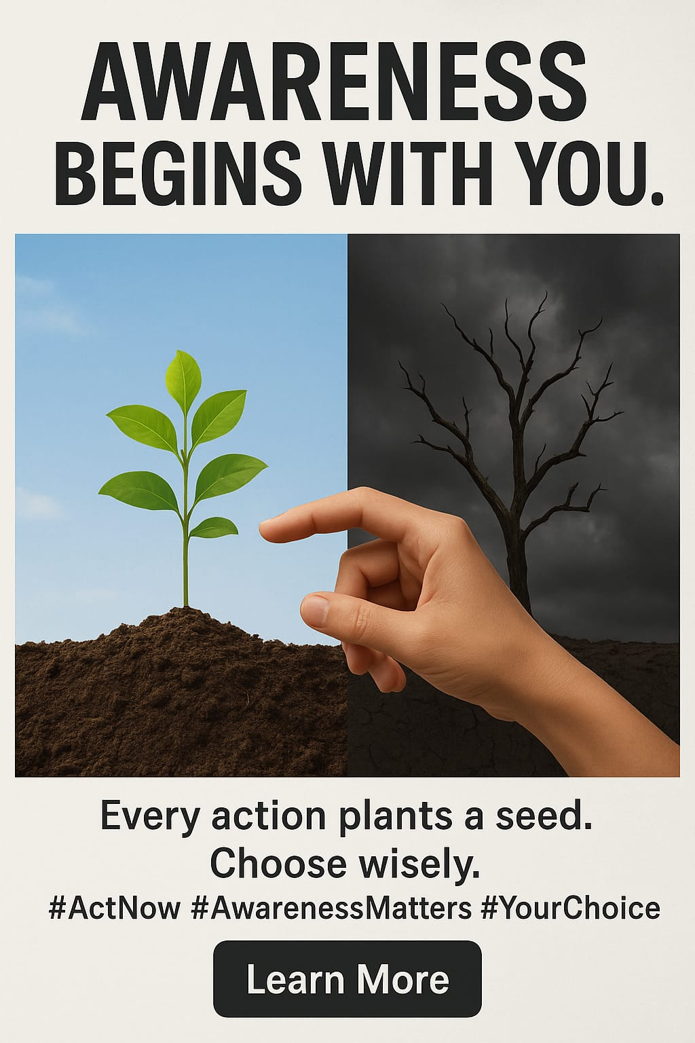

**YOUR SILENCE SHAPES THE FUTURE**

**CONTENT :**

**Poster Title (Big Bold Text):**

**"YOUR SILENCE SHAPES THE FUTURE."**

**Visuals:**

**A split face: one side is vibrant and smiling, the other side is faded and cracked like an old statue.**

**Around the faded side, there are faint words like "pollution," "injustice," "ignorance," etc.**

**Around the vibrant side, words like "hope," "action," "change," "future."**

**Text Below:**

**"Speak up. Stand up. Change begins when you do."**

**#RaiseYourVoice #AwarenessFirst #Be The Change**

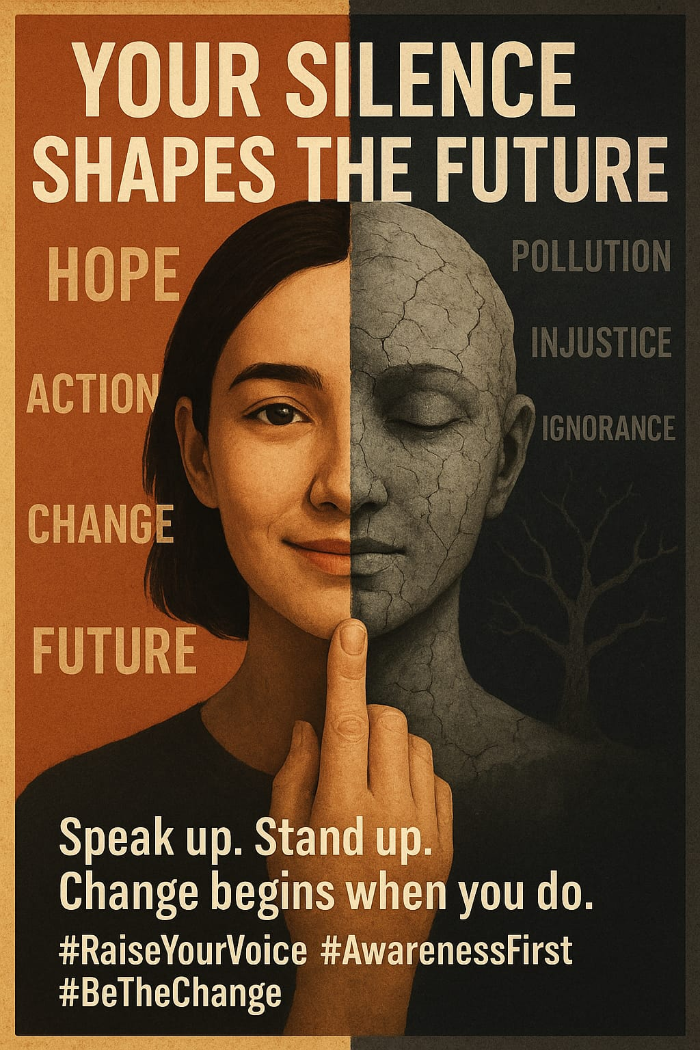

**Thank You for Viewing!**

All designs created by Poojitha for practice and showcase purposes.